CURRICULUM VITAE

Name: | 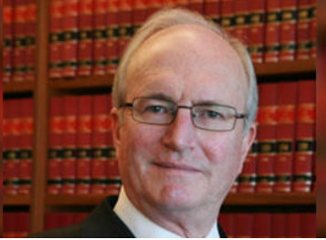  The Hon. Alan ROBERTSON SC
Educational and professional qualifications: | Admitted, Legal Practitioner, Supreme Court of the Australian Capital Territory, 1980
 | Admitted, Barrister, Supreme Court of New South Wales, 1983
 | Bachelor of Laws (Hons), Australian National University, 1980
 | Bachelor of Arts (Hons), Australian National University, 1972
Professional experience: | 2020-2025  2011 to 2020 | Honorary Professor, Australian National University College of Law  Judge, Federal Court of Australia
 | 2016 to 2020  2015 to 2020 | Deputy President, Australian Competition Tribunal  Deputy President, Administrative Appeals Tribunal
 | 1995 to 2011 | Senior Counsel, New South Wales Bar
 | 1983 to 2011 | Private Bar, Sydney
 | 1981 to 1983 | Assistant to Commonwealth Solicitor-General Sir Maurice Byers Kt CBE QC
 | 1973 to 1983 | Commonwealth Public Service, Canberra
Former Memberships: | 2008 to 2011: | Convenor, Constitutional and Administrative Law Section, New South Wales Bar Association
 | 1998 to 2008: | Convenor, Administrative Law Section, New South Wales Bar
 | 1997 to 1999: | Member, CCH Legal Editorial Board
 | 1992 to 1997: | Member, Administrative Review Council (part-time)
 | 1987 to 2009: | Consultant Editor, CCH High Court and Federal Court Practice

