Compliance and Enforcement Policy
V2.0 – December 2021

NDIS Quality and Safeguards Commission
PO Box 210, Penrith NSW 2750.
Copyright
© Commonwealth of Australia 2019
The NDIS Quality and Safeguards Commission encourages the dissemination and exchange of information provided in this policy. The material in this policy is licensed under a Creative Commons Attribution 4.0 International licence, with the exception of:
- the Commonwealth Coat of Arms
- the NDIS Quality and Safeguards Commission logo
- any third party material
- any material protected by a trademark
- any illustration, diagram, photograph or graphic over which the NDIS Quality and Safeguards Commission does not hold copyright, but which may be part of or contained within this policy.
More information on this CC BY licence is set out at the creative commons website: www.creativecommons.org. Enquiries about this licence and any use of this policy can be sent to: communications@ndiscommission.gov.au
Attribution
Use of all or part of these guidelines must include the following attribution:
© Commonwealth of Australia 2019
Using the Commonwealth Coat of Arms
Terms of use for the Coat of Arms are available at this website: https://www.pmc.gov.au/government/commonwealth-coat-arms
Important notice
The information in this policy is for general guidance only. It does not constitute legal or other professional advice, and should not be relied on as a statement of a law in any jurisdiction. You should obtain professional advice if you have any specific concern.
The NDIS Quality and Safeguards Commission has made every reasonable effort to provide current and accurate information, but it does not make any guarantees regarding the accuracy, currency or completeness of that information.
Parties wishing to re-publish or otherwise use the information in this policy must check this information for currency and accuracy prior to publication. This should be done prior to each publication edition, as NDIS Quality and Safeguards Commission guidance and relevant legislation may change. Any queries should be addressed to communications@ndiscommission.gov.au

Table of contents
Table of contents ii
Compliance and enforcement 1
Regulatory framework 1
Human Rights 2
Procedural fairness 2
Compliance and enforcement strategy 2
The compliance pyramid 3
Educate and persuade 4
Investigations 5
Compliance notices 6
Enforceable undertakings 6
Injunctions 7
Infringement notices 7
Civil penalties 7
Vary, suspend or revoke registration 8
Banning orders 9
Reviewable decisions 9

Compliance and enforcement
Monitoring and compliance is important to the NDIS Quality and Safeguards Commission’s work as a regulator. It is one of the ways that the NDIS Commission can encourage best practice among NDIS providers and manage risk to NDIS participants.
The NDIS Commission will work with NDIS providers to help them comply with the new quality and safeguards requirements, including through education and training about their obligations.
The NDIS Commission will monitor registered providers for compliance with the conditions of their registration. Most registered providers must undergo a periodic audit that assesses their performance against the NDIS Practice Standards.
By knowing more about what happens in the NDIS marketplace, the NDIS Commission can work to support ongoing improvement.
The NDIS Commission will also investigate complaints and reports of non-compliance with the NDIS Practice Standards, Code of Conduct and other quality and safeguards requirements where they apply.
The NDIS Commission has the power to investigate any matters relating to registered and unregistered providers and workers. It can impose penalties, including, in the most serious cases, banning workers, de-registering providers and seeking civil penalties.
In determining its response to non-compliance, the NDIS Commission and Commissioner considers a range of factors including:
- the impact of non-compliance on the person with disability, and the broader community
- whether there is any immediate or ongoing risk to the well-being of the NDIS participant
- the seriousness of any non-compliance and the actual or potential harm or consequences
- how far below acceptable standards the conduct falls and the extent to which the person contributed to the risk, including whether it was intentional, reckless, negligent or a mistake
- potential to return the provider to full compliance, and as soon as possible.

Regulatory framework
The NDIS Commission’s regulatory powers and functions are set out in the National Disability Insurance Scheme Act 2013 (the Act) and associated Rules.
These functions are developmental, preventive and corrective, and target individuals, the workforce and providers to:
- strengthen and build capacity
- prevent harm and improve the quality of services
- resolve problems and provide oversight.
Non-compliance may be handled using a mix of tools including education, capacity building and development for people with disability (and their NDIS providers and workers), complaints handling, compliance and enforcement functions and related powers.
The NDIS Commission will take a responsive and proportionate approach to regulation, applying the strongest actions to the most serious issues and breaches.

Human Rights
The NDIS Commission will undertake its regulatory functions in accordance with the Act and with due regard to the United Nations Convention on the Rights of Persons with Disabilities (the Convention).
The NDIS Commission aims to uphold the rights of people with disability, as part of Australia’s commitment to the Convention, to prevent exploitation, violence and abuse of people with disability. The NDIS Commission achieves this through:
- balancing the need to provide appropriate protections, with the need to enable people with disability to exercise choice and control
- focussing on building the capacity of people with disability, their families and carers to make informed decisions about NDIS providers and pursue concerns or complaints
- supporting a responsive and effective NDIS market for disability supports and services.

Procedural fairness
In exercising compliance, investigation and enforcement powers, the NDIS Commission will adhere to the requirements of procedural fairness which means:
- the Commissioner and staff of the NDIS Commission will avoid actual and perceived conflicts of interest and act in an impartial and objective manner
- affording a person an opportunity to be heard before making a decision affecting their interests.

Compliance and enforcement strategy
The NDIS Commission aims to achieve a balance between supporting people with disability to make informed choices, while also promoting high quality supports and services with appropriate safeguards to support the development of a responsive and effective NDIS market.
To achieve these objectives, the NDIS Commission will engage the following integrated strategies:
- encourage compliance with the law by educating and informing providers, participants and others about their rights and responsibilities under the Act
- work with other agencies to implement these strategies, including through coordinated approaches and appropriate referrals
- analyse emerging risks to identify potential market risks to inform compliance and enforcement measures, and identify priorities for regulation
- enforce the law, including through the use of administrative action and by initiating formal enforcement proceedings where that is necessary and appropriate.
If the NDIS Commission has concerns that an NDIS provider may not be complying with legislative requirements, or may become unable to comply, the initial focus of the NDIS Commission’s approach, where appropriate, is to engage with the NDIS provider to support compliance.
Relevant considerations for the NDIS Commission in determining what, if any, further actions are to be taken will include: whether the provider has an understanding of the problem; whether the provider demonstrates a willingness to act to address the problem; whether the provider has a history of non-compliance; whether the non-compliance appears to be serious or systemic.

The compliance pyramid
A wide range of tools, methods and powers are available to the NDIS Commission. The actions to be taken will be determined on a case by case basis, including:
- the seriousness of the issue
- the appropriateness of the person’s response
- the likelihood of further harm.
The compliance and enforcement actions available to the NDIS Commission are:
- administrative (these actions include education, formal warning letters, complaints resolution, compliance notices, infringement notices, revoking registration, and bans) or
- court-based (these actions include injunctions, taking action to enforce an undertaking, and civil penalties).
Administrative measures may enable earlier resolution than court action, and may also lend themselves to achievement of appropriate and timely outcomes that are in the participant’s, provider’s and/or public interest.
Information gathering, inquiry and monitoring powers will be used to help prevent people with disability from experiencing harm arising from poor quality or unsafe supports or services.
A monitoring activity, such as a site visit or regular contact with people working in the NDIS market, may assess compliance with the Act generally or may target particular responsibilities or obligations. This will help the NDIS Commission to make decisions about any further regulatory actions or support that may be necessary.
The Ayres & Braithwaite regulatory pyramid helps to illustrate how the NDIS Commission works to support participants’ choice and control and to support a responsive and effective NDIS market.
Figure 1: Compliance Pyramid

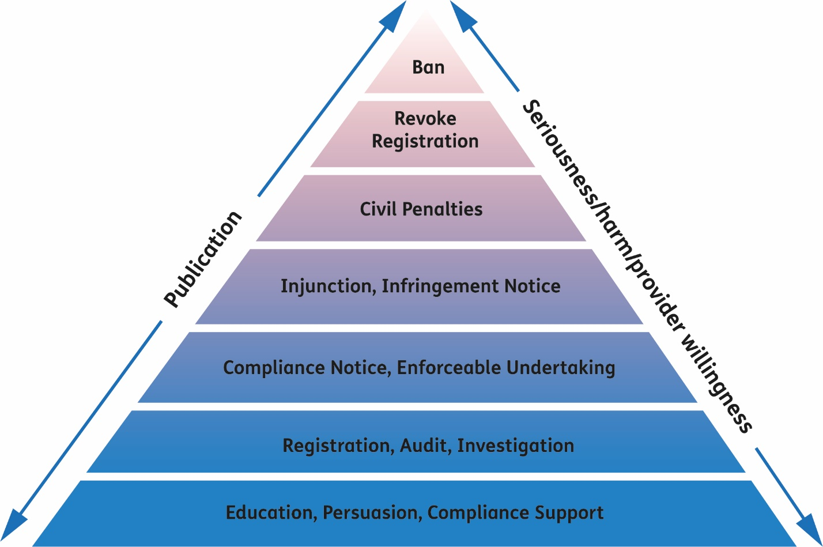
The pyramid helps to show how the NDIS Commission takes a responsive and proportionate approach to regulation, applying the strongest actions to the most serious issues and breaches. It also demonstrates the ability to escalate actions if an initial response does not achieve the intended outcome.
Some actions or regulatory tools are alternatives, while others are used in combination. Using a range of tools from the base of the pyramid may often achieve compliance fairly quickly without needing to escalate to more serious enforcement action, if appropriate. However, it is also open to the NDIS Commission to proceed directly with the strongest actions in a particular case.

Educate and persuade
The primary approach to achieving ongoing compliance and building the capacity of the sector is to educate, advise and encourage NDIS providers and workers to identify and understand their obligations and improve their practice.
Measures may include practical advice to improve outcomes, targeted education and outreach activities, engaging with the regulated community at the earliest possible stage, and providing timely information and advice through the NDIS Commission website, social media, and information sessions.
Such measures help to:
- raise awareness of the benefits of compliance, and the various measures that will be taken to address non-compliance
- remove barriers to compliance, such as lack of awareness about obligations, confusion with other regulators, or particular accessibility needs
- promote the objects of the Act, Practice Standards and NDIS Code of Conduct
- support a reduction in restrictive practices
- reduce the risk that people will inadvertently take action that constitutes a breach.
Having provided advice or guidance to achieve compliance and being satisfied a provider has taken timely and satisfactory steps to remedy a breach, the NDIS Commission may decide to take no further action.
If a provider is not making timely progress to rectify non-compliance the NDIS Commission will consider what additional action may be required to ensure the provider meets their responsibilities.

Investigations
The NDIS Commission will work with NDIS providers to support compliance with the new quality and safeguards requirements, including through education and training about their obligations.
The NDIS Commission may also investigate complaints and reports of non-compliance with the NDIS Practice Standards, NDIS Code of Conduct and other legislative requirements. The NDIS Commission can commence an own motion investigation into any matter relating to compliance by registered and unregistered providers and workers.
The NDIS Commission can exercise monitoring investigation powers (under Part 2 of the Regulatory Powers (Standard Provisions) Act 2014 (Regulatory Powers Act) to check compliance with the Act or whether any information provided pursuant to the Act is correct. Broader investigation powers under Part 3 of the Regulatory Powers Act can be used where there is a suspicion that there has been non-compliance with any civil penalty or offence provision.
The NDIS Commission’s information gathering powers under section 55A of the Act can be utilised regardless of whether or not there has been non-compliance in accordance with the functions of the NDIS Commission.
An investigation is the process of seeking information about alleged, apparent or potential non-compliance, and may support, precede or follow other action taken by the NDIS Commission.
NDIS Commission staff follow the Australian Government Investigations Standards and a range of other statutory requirements and policies, including:
- Regulatory Powers Act
- Prosecution Policy of the Commonwealth
- Guidelines on Disclosure to CDPP by Investigative Agencies
- Legal Services Directions under the Judiciary Act 1903
- Australian Public Service (APS) values and APS Code of Conduct
- Australian and New Zealand Risk Management Standards (AS/NZ ISO 31000:2009)
- Crimes Act 1914

Compliance notices
A compliance notice is a direction to a provider to do specified things or refrain from doing specified things where the NDIS Commission believes or suspects that there has been non-compliance with the Act.
Where there is a history of non-compliance or of the provider failing to co-operate and engage with the NDIS Commission, or where the non-compliance poses a significant risk to the health, safety and wellbeing of people with disability, a compliance notice may not be appropriate.
A compliance notice:
- must briefly set out the non-compliance or suspected non-compliance together with the action to be taken by the provider
- must also set out a reasonable time for the provider to take remedial action to rectify the non-compliance
- may also require the provider to produce evidence of the action taken to address the non-compliance.
Failure to comply with the requirements of a compliance notice may result in a civil penalty.

Enforceable undertakings
An enforceable undertaking is a legally binding agreement that may be entered into as an outcome of compliance activity, a complaints resolution process, such as conciliation, or as an alternative to civil penalty proceedings.
An enforceable undertaking is a written agreement committing the provider to a specific action (or inaction) in order to prevent, or respond to, the contravention of a provision of the Act. It provides an opportunity for significant improvement and/or reform to occur. An enforceable undertaking can be entered into in relation to a contravention or alleged contravention of the Act.
Undertakings provide a remedy other than financial sanctions, such as those that may be applied as a result of civil penalty proceedings. The NDIS Commission is able to apply to the Federal Court to have the undertaking enforced. The court may make any order it sees fit, including orders that the provider comply with the undertaking or pay a pecuniary penalty.
The availability of an enforceable undertaking in connection with a contravention will involve consideration of a number of factors, including:
- the nature and extent of a contravention
- the quality of the remedial action proposed and the extent to which it achieves measurable improvements for the safety of people with disability;
- the person’s capacity and willingness to meet the undertaking
- the likelihood that the enforceable undertaking will deliver real benefits to people with disability, the NDIS market or community beyond that which would normally be expected of a provider.
An enforceable undertaking will generally not be accepted in circumstances where there has been a serious contravention causing harm to a person with disability.

Injunctions
An injunction can be used to compel a person to take certain action, or to refrain from taking certain action.
The NDIS Commission may seek an injunction from a court where:
- there is a serious risk to the health, safety or wellbeing of people with disability that has not been remedied
- other mechanisms available to the NDIS Commission have not resulted, or are not likely to result, in compliance being secured.
Injunctions may be used to restrain a provider from contravening a provision of the Act, or to compel compliance with a provision of the Act. Injunctions can be sought from a court to prevent conduct, require a provider to engage in certain conduct whether or not the specified conduct is occurring, has occurred in the past, or is likely to give rise to an imminent danger to people with disability.
This ensures that a court can prevent or require conduct to uphold the purposes of the Act without having to wait for non-compliance to occur.

Infringement notices
The NDIS Commission may give a person an infringement notice in response to an alleged breach of a civil penalty provision of the Act and as an alternative to taking court action. An infringement notice gives a person a chance to avoid court action over an alleged contravention by paying the penalty stated in the notice.
Paying an infringement notice is not an admission of liability. Payment of the penalty within the time specified means that court proceedings seeking a civil penalty cannot be brought against the person in relation to the alleged contravention.
If the person given an infringement notice chooses not to pay the penalty, then the NDIS Commission may bring court proceedings to have the court order the person to pay a financial penalty (which may be a greater amount than that stated in the infringement notice).
See the NDIS Commission’s Infringement notice policy.

Civil penalties
A civil penalty is a financial penalty imposed by a court. Civil penalties are not criminal matters and do not result in a person being convicted of an offence. The aim of civil penalties is to deter people from breaching the law. The sections of the Act which carry a civil penalty for non-compliance are as follows:
Table 1 - Civil Penalty Provisions
Requirement | Maximum Penalty Units
Registered NDIS providers must comply with conditions of registration | 250 units (individual)  1250 units (corporation)
Failure to comply with NDIS Code of Conduct | 250 units (individual)  1250 (corporation)
Requirement to be a registered NDIS provider | 250 units (individual)  1250 (corporation)
False or misleading information or documents in application to become a registered provider | 60 units (individual)  300 (corporation)
Record keeping by registered NDIS providers (because it is a condition of registration) | 250 units(individual)  1250 (corporation)
Record keeping by former registered NDIS providers | 60 units (individual)  300 (corporation)
Victimisation of a person who discloses information (whistle-blower) prohibited | 500 units (individual)  2500 (corporation)
Failure to comply with a compliance notice | 60 units (individual)  300 (corporation)
A person engages in conduct that breaches a banning order made against that person | 1000 units (individual)  5000 (corporation)
The maximum penalty units (as set out in the table) applicable to each provision demonstrate the seriousness of the breach. Where the person who has breached a civil penalty provision is a body corporate the maximum penalty payable is 5 times the prescribed penalty units. Currently, one penalty unit equals $222.
Any conduct that is ancillary to the contravention of a civil penalty provision is taken to be a contravention of the provision. Ancillary conduct includes any attempt to contravene a provision, aiding or inducing a contravention of a civil penalty provision, or conspiracy to contravene a civil penalty provision.
A provider is responsible for the actions of any of its workers in relation to the contravention of a civil penalty provision.

Vary, suspend or revoke registration
The NDIS Commission may decide to vary, suspend or revoke a provider’s registration in order to deal with inappropriate conduct or practices. Such action is a protective measure and may be undertaken even where steps have been taken to remedy a contravention or where a provider has otherwise been the subject of more formal compliance action.
The NDIS Commission may vary the registration of a registered NDIS provider at the NDIS Commission’s own initiative at any time. Possible variations to a registered NDIS provider’s registration include:
- imposing, varying or revoking conditions to which the registration is subject
- reducing the period for which the registration is in force
- placing limits on the supports or services the provider is authorised to provide.
As the variation, suspension or revocation of a provider’s registration may have serious consequences for people with disability and the provider, the NDIS Commission will balance these considerations with the paramount need to prevent harm to people with disability when making a decision.

Banning orders
The NDIS Commission may make a banning order that prohibits or restricts specified activities by a provider or a person employed or otherwise engaged by a provider.
A banning order is one of the most serious regulatory responses to prevent a person from providing supports or services in the NDIS market. It is intended to apply to an NDIS provider or person employed or otherwise engaged by an NDIS provider in circumstances where it is the most appropriate regulatory option available to prevent people with disability from experiencing harm arising from poor quality or unsafe services provided under the NDIS. The civil penalty in relation to this provision of the Act is therefore substantial, to indicate the serious nature of non-compliance with a banning order.
A banning order may only be made, in accordance with natural justice principles, where the person has been given an opportunity to make submissions to the Commissioner on the matter, except in the following circumstances:
- where there is immediate danger to the health, safety or wellbeing of a person with disability
- where the NDIS Commission has revoked the registration of the NDIS provider.
Where the NDIS Commission is satisfied that it is appropriate to do so, it may vary or revoke a banning order. This may be done on the NDIS Commission’s own initiative or on application by the person against whom the order was made.

Reviewable decisions
A person can seek review of certain types of decisions if they are directly affected by the decision. When the NDIS Commission undertakes this review, it is known as an internal review.
An internal review must be undertaken by an officer of the NDIS Commission who was not involved in making the original decision.
A request for review may be made to the NDIS Commission by:
- sending or delivering a written request by mail or email
- making an oral request, in person or by phone, or other means to the Commissioner.
A person affected by a decision who is not satisfied with the outcome of an internal review may apply for the decision to be reviewed by the Administrative Appeals Tribunal (AAT).
The decision stays in place until and unless another decision is made. However, a person may request that the AAT make an order staying or otherwise affecting the implementation of the decision.
Table 2 - Decisions Subject to Review
Decision | Section
A decision to refuse to register a person as a registered NDIS provider | s 73E
A decision to impose conditions to which a person’s registration as a registered NDIS provider is subject | s 73G
A decision to vary, or refuse to vary, the registration of a registered NDIS provider | s 73L
A decision to suspend the registration of a registered NDIS provider | s 73N
Aa decision to revoke, or not to revoke, the registration of a person as a registered NDIS provider | s 73P
Aa decision to give a compliance notice to an NDIS provider | s 73ZM
A decision to make a banning order | s 73ZN
A decision to vary, or to refuse to vary or revoke, a banning order | s 73ZO

I. Ayres and J. Braithwaite (1992) Responsive Regulation: Transcending the Deregulation Debate. New York: Oxford University Press. http://johnbraithwaite.com/monographs/

